VMW 261: In-class quiz #2

|  |  |
| --- | --- |
| Name: |  |

**Instructions**

Read each question carefully and circle the correct answer. When you are done, bring your quiz up to Russ ☺

1. What is true of the typical rootstocks used in modern day grapegrowing.
   1. They are immune to phylloxera
   2. They are tolerant of phylloxera
   3. They generally confer more vigor than when vines are own rooted
   4. They are immune to nematodes
2. Which of these might be a reason for using a rootstock with *V. berlandieri* parentage?
   1. Ease of grafting
   2. You have wet soils
   3. You need a rootstock to advance maturity
   4. You have soils with a lot of available K+
3. Which of these species is the least drought tolerant?
   1. *V. aestivalis*
   2. *V. rupestris*
   3. *V. riparia*
   4. *V. berlandieri*
4. What am I pointing at?

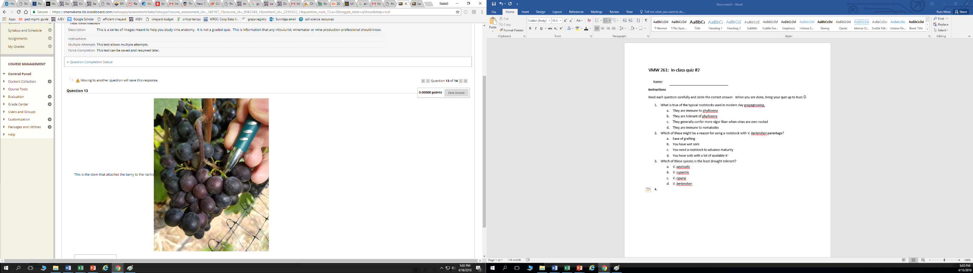

* 1. The peduncle
  2. The pedicel
  3. The petiole
  4. The podiatrol

1. The two major root flushes in grape vines generally occur when?
   1. Just prior to bloom and just after harvest
   2. Just prior to budbreak and just before harvest
   3. Just after bloom and before harvest
   4. In dormancy and at veraison

**Extra credit**

1. What is a reason for post – harvest nutrition and irrigation in Walla Walla?
   1. To improve soil health
   2. To improve grape/wine quality
   3. To increase carbohydrate reserves going into the winter
   4. There is no point. They don’t know what they’re doing